
JKKI: Jurnal Kedokteran dan Kesehatan Indonesia
Indonesian Journal of Medicine and Health
Journal homepage: https://journal.uii.ac.id/JKKI
P-ISSN 2085-4145 | E-ISSN 2527-2950
Title of the article, written in Cambria font, size 14, bold, single-spaced, maximum 20 words: Subtitle can be used to explain a long title, avoid non-standard abbreviations
First Author,*¹ Second Author,² Third Author²
¹Department of X, Faculty of Y, University of Z, Province, Country
²Department of A, Hospital B, Province, Country
Article Info: | Article History:
Keywords: keyword 1; keyword 2; keyword 3; keyword 4; keyword 5 | Received:  Accepted:  Online:
*Corresponding author:  email@email.ac.id | DOI:
Systematic Review

ABSTRACT
The abstract contains about 250-300 words and should be an objective representation of the article. Please use an unstructured abstract containing background, objectives, methods, results, and conclusions. The background consists of a maximum of three sentences and raises questions addressed in a broad context. It should state clearly the objective(s) or question(s) of this review. Also, it describe briefly the main methods (eligibility criteria, information sources, risk of bias, synthesis of results). The methods should be written in past tense. The methods must include the total number of included studies and participants and summarise relevant characteristics of the studies. The results should present main outcomes, preferably indicating the number of included studies and participants for each. If the meta-analysis was done, the summary estimate and confidence/credible interval must be reported. If comparing groups, please indicate the direction of the effect (i.e. which group is favoured). A general interpretation of the results and important implications also should be elaborated.

INTRODUCTION
The introduction should briefly place the study in a broad context and highlight why it is important. It should be written clearly comprising general background, state of the art, novelty and originality (compared to previous literatures and providing references as original research articles within 10 years), problems and hypotheses (if any), purposed problem solving (if any). In the text, the citation can be written at the end of the sentences using the Vancouver style.¹ It should define the purpose of the study and its significance. The current state of its research field should be reviewed carefully, and key publications should be cited.
The authors also must highlight controversial and diverging hypotheses when necessary. As far as possible, the introduction should be comprehensible to scholars outside their field of research.²⁻⁴ This section should be written without subtitles and contain background information such as prior work and the objectives of study. It also should describe the rationale of the study (need and significance). The authors should summarise the previous relevant research and explain their findings (pro and contra results). Also, they must describe the novelty and the objective of their study.⁵
Authors can be also stated in the text, for example a study by Sulistyoningrum et al. (2015) stated that introduction is recommended to be written in 3-5 paragraphs length neither too long nor too short.⁶ Also it needs to state the contribution of the current research to the health and medicine development in Indonesia, emphasizing its importance to Indonesia. Finally, it briefly mentions the main aim of the study and preferably highlights principal conclusions.

METHODS
Methods should be described with sufficient details to allow others to replicate and build on published results.

Eligibility criteria
This part specifies the inclusion and exclusion criteria for the review and demonstrates how studies were grouped for the syntheses.

Information sources
This part specifies all databases, registers, websites, organisations, reference lists and other sources searched or consulted to identify studies. It also should specify the date when each source was last searched or consulted.

Search strategy
This part presents the full search strategies for all databases, registers and websites, including any filters and limits used.

Selection process
This part specifies the methods used to decide whether a study met the inclusion criteria of the review, including how many reviewers screened each record and each report retrieved, and whether they worked independently. If applicable, this may point out details of automation tools used in the process.

Data items
This part lists and defines all outcomes for which data were sought. It specifies whether all results compatible with each outcome domain in each study were sought (e.g. all measures, time points, analyses); and if not, it can specify methods used to decide which results to collect. Then it lists and defines all other variables for which data were sought (e.g. participant and intervention characteristics, funding sources). Finally, it describes any assumptions made about any missing or unclear information.

Study risk of bias assessment
This part specifies the methods used to assess risk of bias in the included studies, including details of the tool(s) used and the number of reviewers assessing each study (and whether they worked independently); and if applicable, it can demonstrate details of automation tools used in the process.

Effect measures
This part specifies, for each outcome, the effect measure(s) (e.g. risk ratio, mean difference) used in the synthesis or presentation of results.

Synthesis methods
This part describes processes used to decide which studies were eligible for each synthesis (e.g. tabulating the study intervention characteristics and comparing against the planned groups for each synthesis). It also describes any methods required to prepare the data for presentation or synthesis, such as handling of missing summary statistics, or data conversions. Then it should describe any methods used to tabulate or should visually display results of individual studies and syntheses. Next, it describes any methods used to synthesize results and provides a rationale for the choice(s). If a meta-analysis was performed, it must describe the model(s), method(s) to identify the presence and extent of statistical heterogeneity, and software package(s) used. In addition, it describes any methods used to explore possible causes of heterogeneity among study results (e.g. subgroup analysis, meta-regression). The last, it describes any sensitivity analyses conducted to assess robustness of the synthesized results.
RESULTS
The results should be equipped with tables and figures. The maximum cumulative number of tables and figures is 6 in 1 manuscript. The tables and figure must be inserted efficiently without duplication. One result only needs to be presented in one presentation from either figure or table, but not both. The tables and figures must be titled; both titles should be placed aligned left and suitable for the image and table. Any abbreviations written in the tables or figures must be explained below the tables and figures.

Study selection
This part describes the results of the search and selection process, from the number of records identified in the search to the number of studies included in the review, ideally using a flow diagram.

Study characteristics
This part cites each included study and presents its characteristics.

Risk of bias in studies
This part presents assessments of risk of bias for each included study.

Results of individual studies
This part presents, for all outcomes and for each study,(a) summary statistics for each group (where appropriate) and (b) effect estimates and its precision (e.g. confidence/credible interval), ideally using structured tables or plots.

Results of syntheses
This part briefly summarise, for each synthesis, the characteristics and risk of bias among contributing studies. It presents results of all statistical syntheses conducted. If the meta-analysis was done, each the summary estimate and its precision (e.g. confidence/credible interval) and measures of statistical heterogeneity should be presented. If comparing groups, the direction of the effect should be demonstrated. Also, this part presents results of all investigations of possible causes of heterogeneity among study results. Then presenting results of all sensitivity analyses conducted is to assess the robustness of the synthesized results.

Tables
The tables should be numbered in the text sequentially, written in single-space with Cambria size 10 (Table 1). The table title should be precise, clear, and located above the table. Please do not use internal horizontal or vertical lines; the border is only used in the column headings and the end of the tables. The tables must be placed after they were discussed in the text.
Table 1. Reporting guidelines to report main study types
Study types | Recommended reporting guidelines | Useful links
Randomised trials | Consolidated Standards of Reporting Trials or CONSORT | https://www.equator-network.org/reporting-guidelines/consort/
Observational studies | STrengthening the Reporting of OBservational studies in Epidemiology or STROBE | https://www.strobe-statement.org/
Diagnostic/prognostic studies | Standards for Reporting of Diagnostic Accuracy (STARD) | doi: 10.1007/s11606-008-0583-3
Diagnostic/prognostic studies | APPRAISAL OF GUIDELINES FOR RESEARCH & EVALUATION II (AGREE II) | doi: https://doi.org/10.1136/bmj.i2027
Qualitative research | Standards for Reporting Qualitative Research (SRQR) or  Consolidated criteria for reporting  qualitative research (COREQ) | 0.1093/intqhc/mzm042  DOI: 10.1097/ACM.0000000000000388
Animal pre-clinical studies | ARRIVE (Animal  Research: Reporting of In Vivo Experiments) | DOI: 10.1371/journal.pbio.3000410

The authors should place explanatory matter in footnotes, not in the heading. If the tables contain numbers, please use (.) to separates decimals (limited to only 2 decimals). Any statistical values should be written in 3 decimals. Any symbols must be placed properly and described in the caption (Table 2).

Table 2. Elements of benefits of implementing MSS health in Lumajang Regency
Compound name | Assay/method |  | Targeted DENV serotype and cell line used | Study parameters
Quercetin⁵³ | MTT assay, RT-PCR, molecular docking | DENV-2 strain NGC, Huh7it-1 |  | - IC₅₀= 1.1 μg/ml  - CC₅₀= 38.8 μg/ml  - SI= 38
Isobutyl gallate⁵⁴ | MTT assay, FAA | DENV-2 strain New Guinea C (NGC), Huh7 it-1 |  | - CC₅₀= 167.19 µg/mL  - IC₅₀= 4.45 µg/mL  - SI= 25.69
Curcumin⁴⁵ | MTT assay, plaque assay | - Virus: DENV­1 strain JMB­034, DENV­2 strain SUB­011, DENV­3 strain SUB­006, and DENV­4 strain SUB­007  - Cell line: alveolar epithelial carcinoma A549, fibroblast BHK­21 |  | - IC₅₀=20.60 µM (DENV-1); 13.95 µM (DENV-2); 25.54 µM (DENV-3); 12.35 µM (DENV-4)  - CC₅₀= 108 µM
6-gingerol⁴⁵ | MTT assay, plaque assay | - Virus: DENV­1 strain JMB­034, DENV­2 strain SUB­011, DENV­3 strain SUB­006, and DENV­4 strain SUB­007  - Cell line: alveolar epithelial carcinoma A549, fibroblast BHK­21 |  | - IC₅₀= 14.70 µM (DENV-1),14.17 µM (DENV-2), 78.76 µM (DENV-3), 112.84 µM (DENV-4)  - CC₅₀= 210 µM
MSS: Minimum Service Standards

Figures
Figures should be professionally drawn. photographed or submitted as high-quality digital prints. They also should be sequentially numbered and provide information related to their results that are presented in texts without duplication. Important points in the figures must be annotated and described in the caption or figure legend, which should be written in Cambria size 10. Histological pictures must be accompanied by the staining method and magnification (Figure 1).
Initial submissions do not require high-resolution image files, but images must be of sufficient resolution for reviewers to properly evaluate the data. It is suggested that they must be incorporated with the manuscript text into a single Word document at initial submission, but separated image files may be supplied if necessary. Should your manuscript be accepted, you will receive more extensive instructions for final submission of display items. However, some guidelines for the preparation of final figures are provided below if you wish to minimize subsequent revisions and potential delays. The images should be in RGB colour and at a resolution of 300 dpi or high. The authors should use the same typeface (Cambria) for all figures.

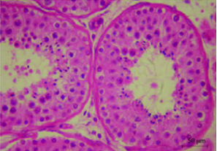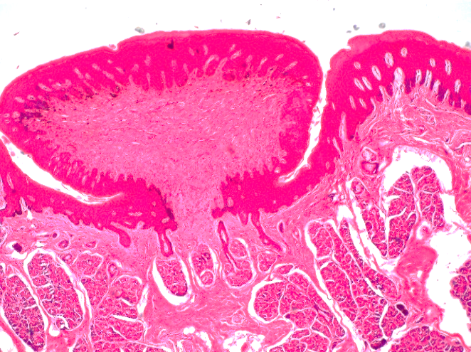
A
B
Figure 1. Some examples of histopathological pictures. A. tubuli seminiferi with germinal epithelium (red arrow), B. lingual papilla with von Ebner gland (black arrow). Haematoxylin-Eosin staining, 400X magnification

One figure can be explained as a maximum of four relevant figures. The title of the figures should be short and clear and located below the image. Important points in the figure must be annotated and described in the caption or figure legend, which should be written in Cambria size 10. Statistical figures should be equipped with axis titles (Figure 2).

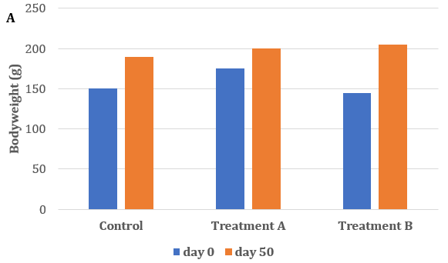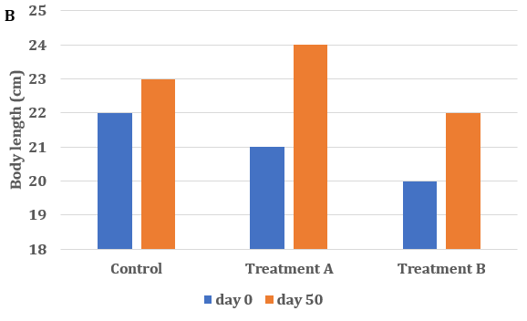
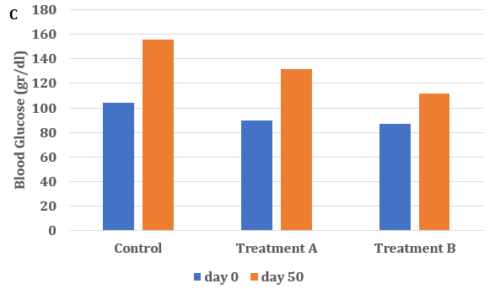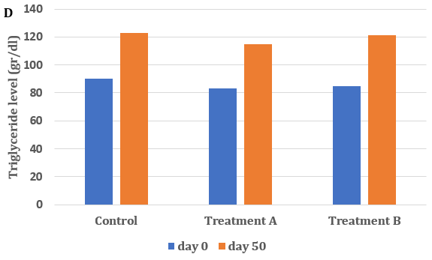
Figure 1. Comparison of anthropometric and biochemicals parameters among groups before and after treatment. A. Bodyweight, B. body length, C. Blood glucose level and D. triglyceride level

DISCUSSION
This section should not be divided by subheadings. It must summarise general interpretation of the results in the context of other evidence. It also explains why any limitations of the evidence included in the review and any limitations of the review processes. The findings and their implications should be discussed for practice, policy, future research and Sustainable Development Goals (SDGs) if possible. The length of the article should be 3,500-5,000 words (from introduction to conclusion; figures and tables excluded).

CONCLUSION
A single paragraph consists of conclusions. The conclusions should be the answer to the objectives of the review.

CONFLICT OF INTEREST
The authors should make a conflict-of-interest disclosure statement or a declaration that they do not have any conflicts of interest. They should disclose at the time of revision any financial arrangement they may have with a company whose product is pertinent to the submitted manuscript or with a company making a competing product. Such information will be held in confidence - while the paper is under review - and will not influence the editorial process.

REGISTRATION AND PROTOCOL
The author should provide registration information for the review, including register name and registration number, or state that the review was not registered.

ACKNOWLEDGMENTS
In this section, the authors can acknowledge any support given. Anyone (individual/company/institution) of important intellectual content who has substantially contributed to the study must be acknowledged. The acknowledgement is only for persons who have made substantive contributions to the study. This section may also include funding. This may also include administrative and technical support, or donations (e.g., materials used for experiments).

DATA AVAILABILITY STATEMENT
The authors are required to include a data availability statement in their manuscript. The data availability statement should clearly explain where the data supporting the research findings can be accessed. If the data are not publicly accessible, the authors must provide a clear reason and explain how to obtain access if upon request.

SUPPLEMENTARY MATERIAL(S)
Data that are not critical to the text or cannot be included in the article due to size or format restrictions can be uploaded as supplementary material during the submission process and displayed alongside the published article.
Supplementary material is not typeset; therefore, the authors must ensure that all information is clearly presented without tracked changes/highlighted text/line numbers, and that the appropriate caption is included in the file.

AUTHOR CONTRIBUTIONS
A paragraph should be included explaining how each author contributed to the manuscript. Names of the authors should be expressed as initials.

DECLARATION OF USING AI IN THE WRITING PROCESS
A paragraph should be included explaining how the author(s) used AI and AI-assisted technologies in the writing process if any.

LIST OF ABBREVIATIONS
UDCA: Ursodeoxycholic Acid; MMP-9: Matrix Metalloproteinase-9; TIMP-1: Tissue Inhibitors of Metalloproteases-1; HSC: Hepatic Stellate Cells; BDL: Bile Duct Ligation; TNF-α: Tumor Necrosis Factor-α; TGF-β1: Transforming Growth Factor-β1; α-SMA: α-smooth muscle actin

REFERENCES
References must be numbered consecutively in the order in which they first appear in the text (including citations in tables and legends) and listed individually at the end of the manuscript. The authors are recommended to prepare the references with a bibliography software package, such as EndNote, Reference Manager or Zotero to avoid typing mistakes and duplicated references. If you use the Mendeley Reference Manager, please use this link to write the References (https://csl.mendeley.com/styles/515400891/Jurnal-JKKI). The reference were not allowed from repositories, unpublished research or unofficial websites. For further information, please refer to the author’s guidelines.

In the text, reference numbers should be placed in superscript and placed after the punctuation. In the reference list, the references should include the names of all authors when six or fewer; when seven or more, list only the first six names and add “et al.” The references should also include full title and source information (Vancouver style). Journal names should be abbreviated as in MEDLINE.

- Winarno ANS. Kerley a line in an 18-year-old female with acute pulmonary edema and chronic kidney disease stage V. JKKI. 2017;8(1):38–44.
- Ouchi Y, Rakugi H, Arai H, Akishita M, Ito H, Toba K, et al. Redefining the older people as aged 75 years and older: Proposal from the Joint Committee of Japan Gerontological Society and the Int J Ger. 2017;1045–7.
- Diabetes Prevention Program Research Group. Hypertension, insulin, and proinsulin in participants with impaired glucose tolerance. Hypertension.2002;40(5):679–86.
- Lewis G. Why Mothers Die. Report on confidential enquiries into maternal deaths in the United Kingdom, 2000-2002. Lewis G, editor. London: RCOG Press; 2004.
- Lock S. Death in Childbirth: An International Study of Maternal Care and Maternal Mortality 1800-1950. London: Oxford University Press; 1992. 338–339. p.
- Council of Europe. Recent Demographic Developments in Europe 2004. Strasbourg, France: Council of Europe Publishing; 2005.
- Desrini S, Ghiffary HM. Comparison of antibacterial activity of Talok (Muntingia calabura L) leaves ethanolic and n-hexane extracts on Propionibacterium acnes. In: AIP Conference Proceedings. 2018.
- Singh S, Henshaw SK, Berensten K. Abortion: a worldwide overview. In: Basu AM, editor. The Sociocultural and Political Aspects of Abortion: Global Perspectives. Westport: Praeger Publishers; 2003. p. 15–47.
- U.S. Bureau of the Census. International Data Base [Internet]. China; 2007 [cited 2009 Aug 12]. Available from: http://www.census.gov/ipc/www/idb/country/chportal.html

